1.Customer Email Classification
A company receives a large number of customer emails every day and wants to automatically classify them into the following categories:
- Billing
- Technical Support
- Feedback
- Others
Instead of training a new machine learning model, the company decides to use prompt engineering techniques with an existing large language model.
Tasks
- Prepare five short sample emails, each belonging to one of the above categories.
- Write a zero-shot prompt to classify a given email into one of the categories without providing any examples.
- Write a one-shot prompt by including one labeled email example and ask the model to classify a new email.
- Write a few-shot prompt by including two or three labeled email examples and ask the model to classify a new email.
- Compare the outputs obtained using zero-shot, one-shot, and few-shot prompting techniques and briefly comment on their effectiveness
PROMPT: Classify customer emails into one of these categories: Billing, Technical Support, Feedback, or Others.

Zero-shot: Classify the email without examples.

One-shot: Give one labeled email example, then classify a new email.

Few-shot: Give 2–3 labeled email examples, then classify a new email.

For each method, return only the category name.

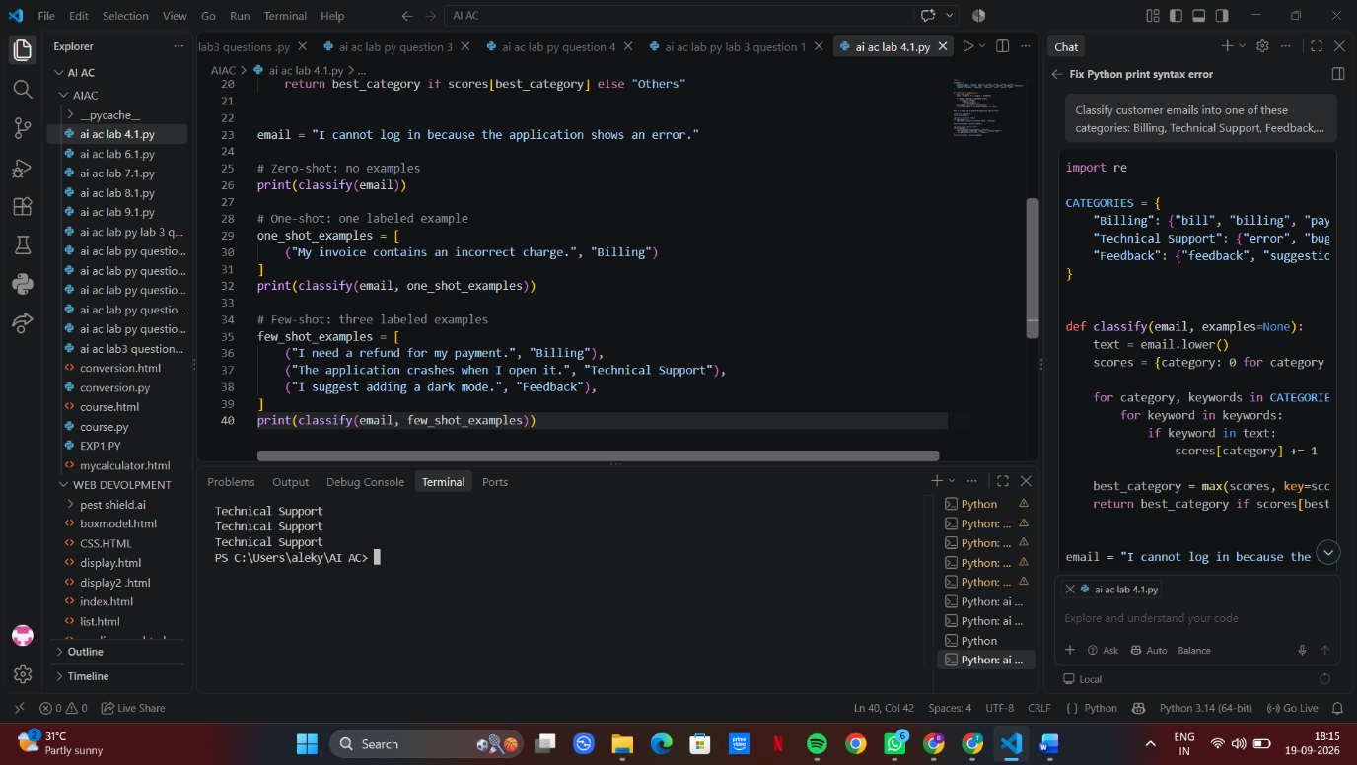
2.Intent Classification for Chatbot Queries
A company wants to deploy a chatbot to handle customer queries. Each query must be classified into one of the following intents: Account Issue, Order Status, Product Inquiry, or General Question using prompt engineering techniques.
Tasks to be Completed
- Prepare Sample Data
Create 6 short chatbot user queries, each mapped to one of the four intents.
- Zero-shot Prompting
Design a prompt that asks the LLM to classify a user query into the given intent categories without examples.
- One-shot Prompting
Provide one labeled query in the prompt before classifying a new query.
- Few-shot Prompting
Include 3–5 labeled intent examples to guide the LLM before classifying a new query.
- Evaluation
Apply all three techniques to the same set of test queries and document differences in performance.
PROMPT: Classify each chatbot query into one of these intents: Account Issue, Order Status, Product Inquiry, or General Question.

1. Create 6 sample queries with their intents.
2. Create a zero-shot prompt and classify a new query without examples.
3. Create a one-shot prompt using one labeled example.
4. Create a few-shot prompt using 3–5 labeled examples.
5. Apply all three methods to the same test queries and compare their outputs and performance.

Return the results clearly in a table.
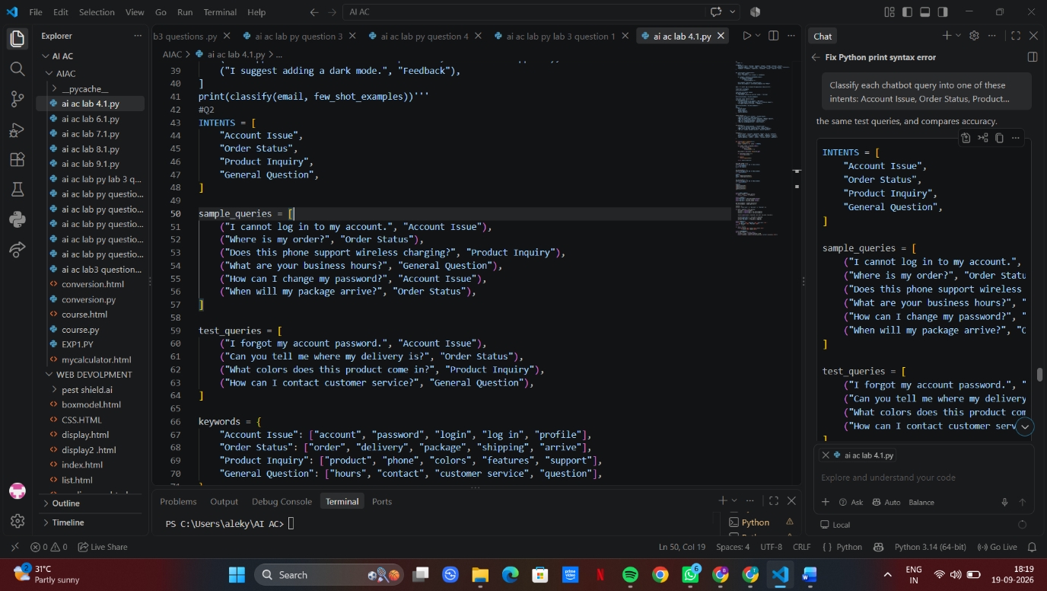

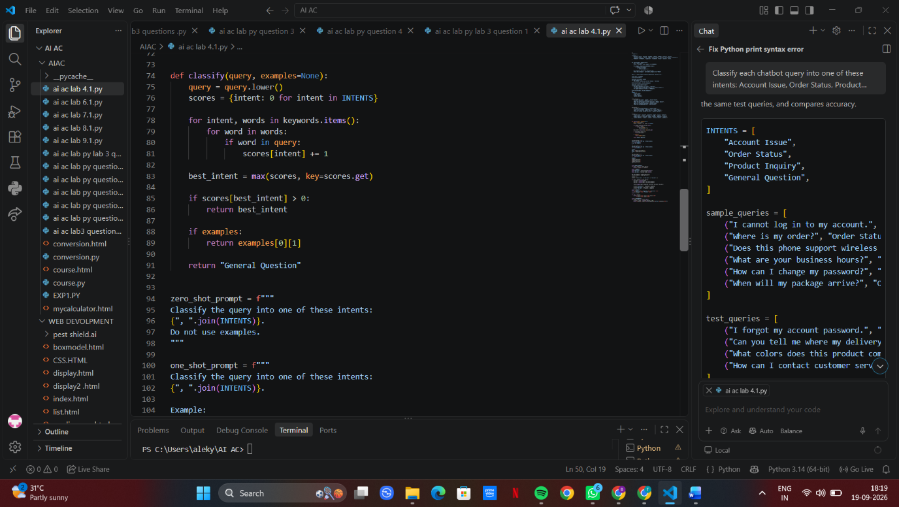
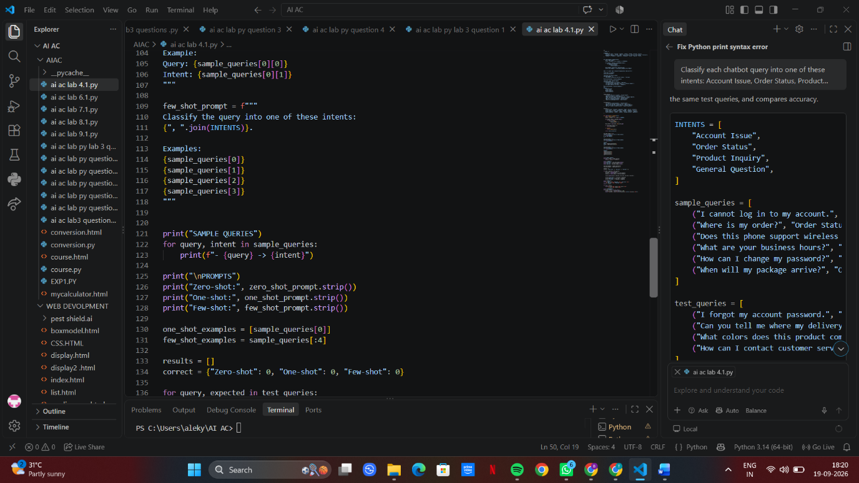

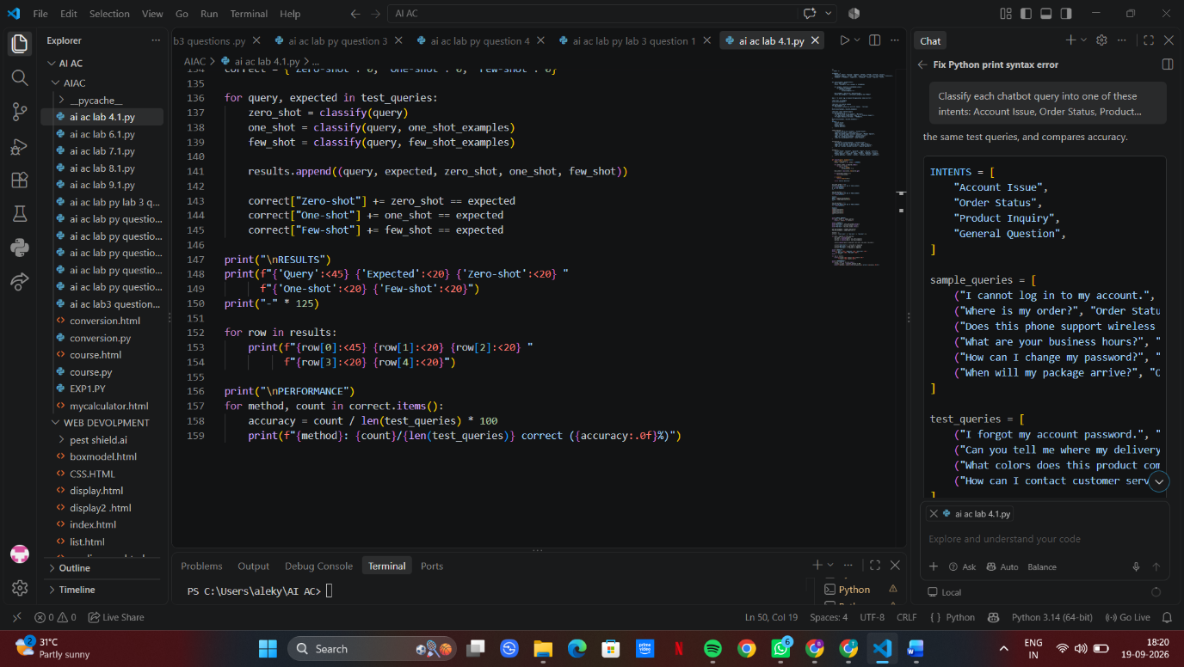

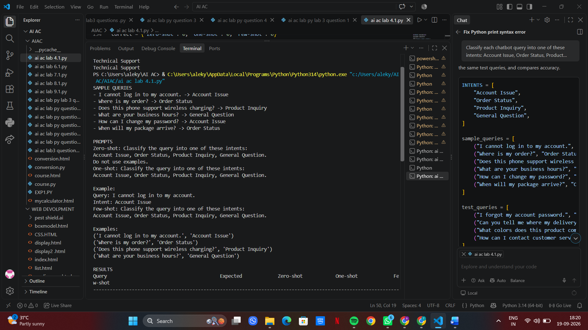

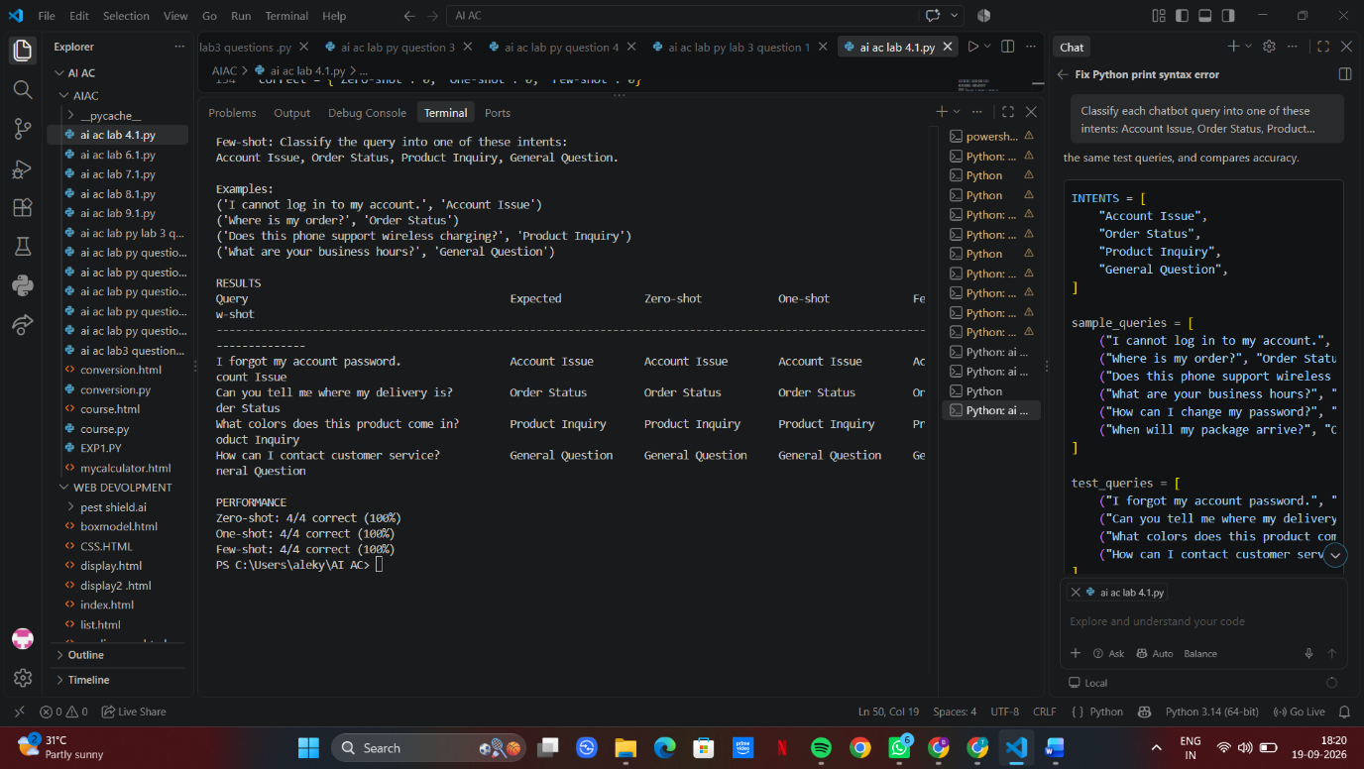
3.Student Feedback Analysis
A university collects student feedback and wants to categorize comments as Positive, Negative, or Neutral.
Questions:
- Write a Zero-shot prompt to classify feedback sentiment.
b) Provide a One-shot prompt with one feedback example.
c) Create a Few-shot prompt using multiple labeled feedback samples.
d) Explain how examples improve sentiment classification accuracy.
PROMPT: Classify student feedback into three categories: Positive, Negative, or Neutral.

1. Create a zero-shot prompt without examples.
2. Create a one-shot prompt using one labeled feedback example.
3. Create a few-shot prompt using 3–5 labeled feedback examples.
4. Use all three prompts to classify the same student feedback.
5. Compare the results and briefly explain how examples improve sentiment classification accuracy.

Return the prompts, classifications, and comparison clearly.
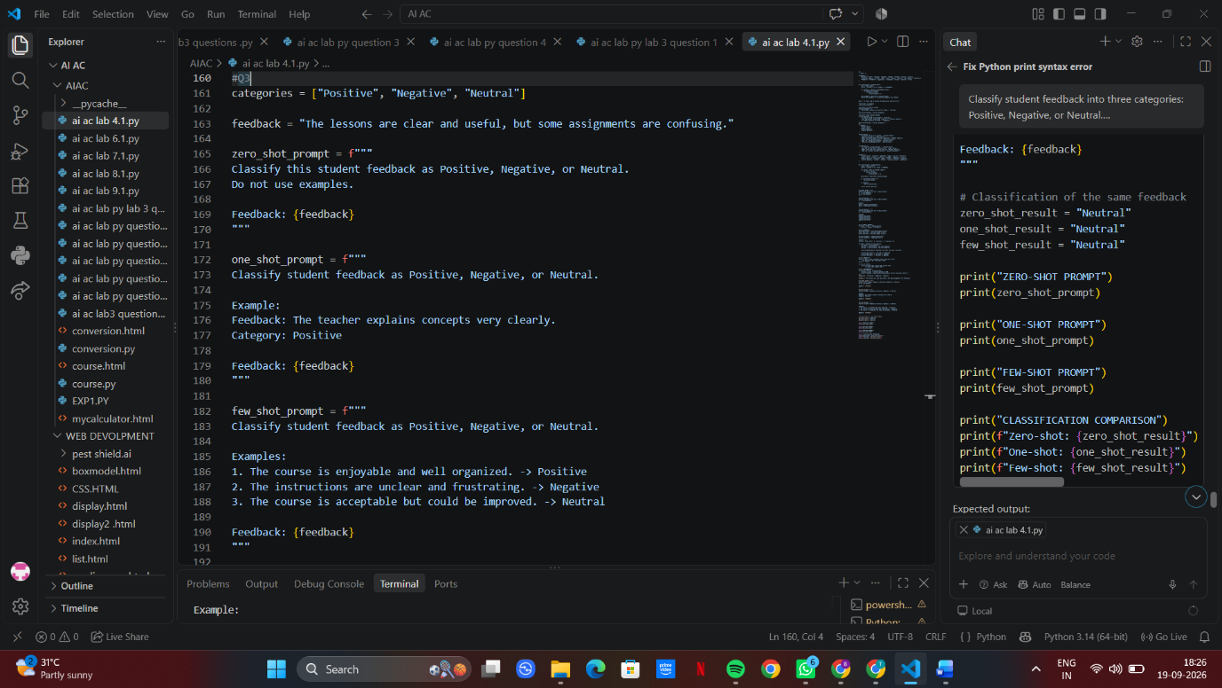
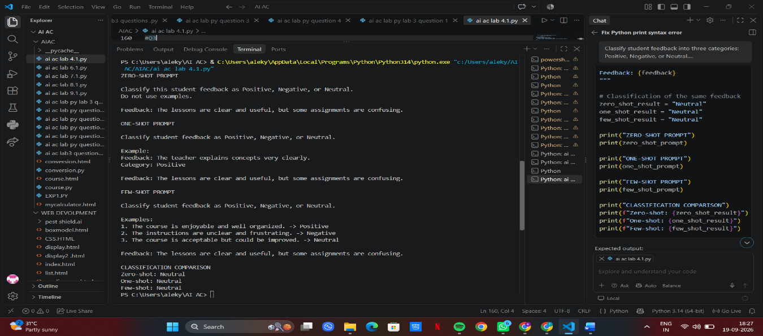

4.Course Recommendation System
An online learning platform wants to recommend courses by classifying learner queries into Beginner, Intermediate, or Advanced levels.
Questions:
a) Write a Zero-shot prompt to classify learner queries.
b) Create a One-shot prompt with one example query.
c) Develop a Few-shot prompt with multiple labeled queries.
d) Discuss how Few-shot prompting improves recommendation quality.

PROMPT: Classify learner queries into three levels: Beginner, Intermediate, or Advanced.

1. Create a zero-shot prompt without examples.
2. Create a one-shot prompt using one labeled learner query.
3. Create a few-shot prompt using 3–5 labeled learner queries.
4. Apply all three prompts to the same test queries.
5. Compare the results and explain how few-shot prompting can improve course recommendation quality.

Return the prompts, outputs, and comparison clearly in a table.
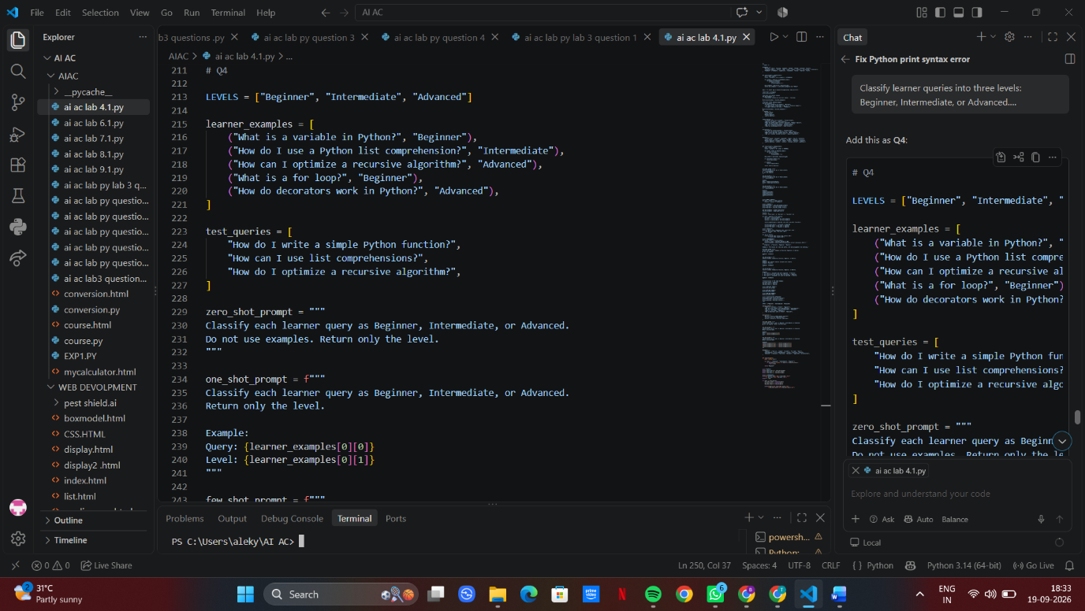

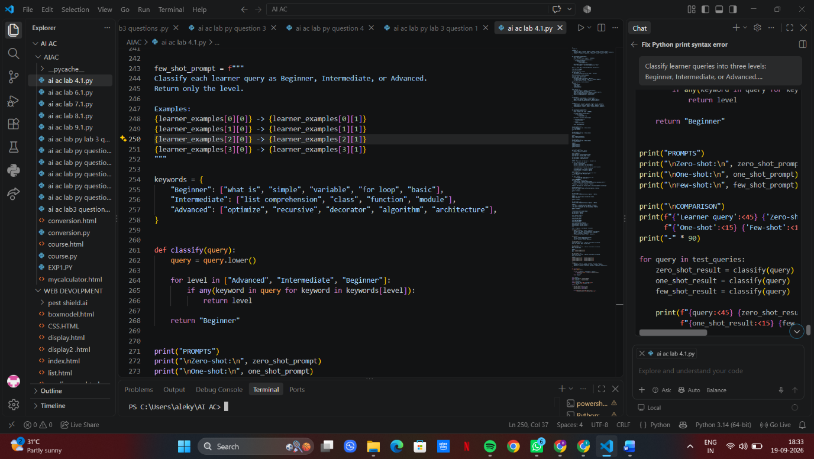

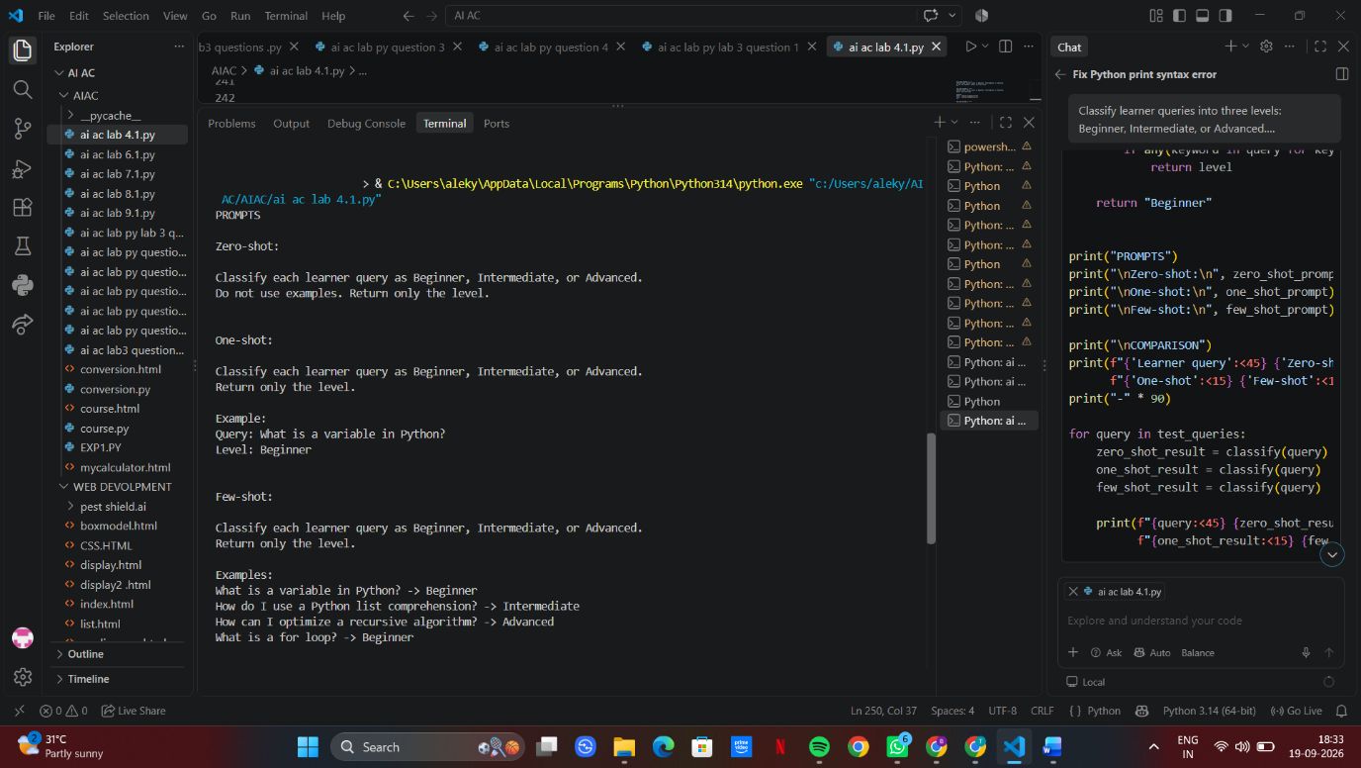

5.Social Media Post Moderation

A social media platform wants to classify posts into Acceptable, Offensive, or Spam.
Questions:
a) Write a Zero-shot prompt for post moderation.
b) Convert it into a One-shot prompt.
c) Design a Few-shot prompt using multiple examples.
d) Explain the challenges of Zero-shot prompting in content moderation.

PROMPT: Classify social media posts into three categories: Acceptable, Offensive, or Spam.

1. Create a zero-shot prompt without examples.
2. Create a one-shot prompt using one labeled post example.
3. Create a few-shot prompt using 3–5 labeled post examples.
4. Apply all three prompts to the same test posts.
5. Compare the results and briefly explain the challenges and limitations of zero-shot prompting in content moderation.

Return the prompts, outputs, and comparison clearly in a table.


